Guideline for Expression of Interest - Expanding Traditional Owner led seagrass monitoring and restoration

Blue Carbon Program

Application Guidelines

Issued 28 April 2023
Acknowledgment of Country: The Great Barrier Reef Foundation extends its deepest respect and recognition to all Traditional Owners of the Great Barrier Reef and its Catchments as First Nations Peoples hold the hopes, dreams, traditions and cultures of the Reef

Contents
Contents 1
1. The Great Barrier Reef Foundation 2
2. About this Expression of Interest 2
3. Available Funding 2
4. Objectives of the Grant Round 3
5. Key Dates 3
6. Information Session 4
7. Eligibility 4
8. What can and can’t be funded? 5
9. The Proposed Approach 6
10. Assessment criteria 7
10.1 Stage One – assessment criteria 7
10.2 Stage Two – assessment criteria 7
10.3 In kind and Co-contributions 9
11. Notification of applicants 9
12. How to apply 10
12.1 Applicant checklist 10
13. Incomplete or late applications 10
14. Reporting 10
15. Further information 10
16. Disclaimer 11
Appendices 11
Appendix A: Seagrass presence/absence at survey sites within the Great Barrier Reef World Heritage Area, 1984-2014. 12
Appendix B: Map of the Great Barrier Reef World Heritage Area and Catchment boundaries 12

The Great Barrier Reef Foundation

The Great Barrier Reef Foundation (GBRF) is the lead charity dedicated to protecting the Great Barrier Reef (the Reef) by funding science, technology, engineering solutions, and on-ground action to ensure its long-term conservation.

We’re solving the most complex and challenging problems facing the survival of the Great Barrier Reef.

The funds we raise are directed at projects with large-scale impact – helping protect coral reefs and the animals that depend on them. Working closely with more than 500 partners, we're regenerating and restoring the Great Barrier Reef and building its resilience in the face of climate change and other major threats.

Learn more about our achievements so far and upcoming work on our website https://www.barrierreef.org/what-we-do/about-us.

About this Expression of Interest

This Expression of Interest (EOI) is inviting applications from Traditional Owner groups of the Great Barrier Reef seeking funding to undertake projects that monitor and/or restore seagrass meadows and associated biodiversity, cultural and carbon values. Potential applicants should read these Guidelines and the Application Form in their entirety before deciding whether to submit an EOI. The complete package comprises:

- Guidelines
- Application Form (EOI)

Available Funding

The Foundation has secured dedicated funding for this round to commit up to $800,000 up until November 2025 for Traditional Owner led projects.

Investment will target between three and five Traditional Owner groups to participate in the project. EOIs and partnerships across multiple Traditional Owner groups are encouraged under a single Application, where objectives align. Depending on needs, number of successful EOIs and resourcing, successful applicants may negotiate up to a value of $300,000 per project. All projects must conclude by November 2025.

Table 1. Available funding.
Program | Available funding
Blue Carbon – Expanding Traditional Owner led seagrass monitoring and restoration. | Maximum $300,000 per project. $150,000 per annum.  There is $800,000 available for the whole funding round.

Objectives of the Grant Round

GBRF recognises that Traditional Owners have been monitoring and caring for their Country for millennia. This program aims to align with Traditional Owner aspirations and priorities, and value-add to existing restoration and monitoring activities to enable Traditional Owners to guide and prioritise management of Sea Country.

The EOI is open to Traditional Owner groups of the Great Barrier Reef seeking to use monitoring tools, technologies and techniques that are new to them to further develop the skills and experience required to lead on ground monitoring and restoration of blue carbon ecosystems (particularly seagrass). It can provide funding support for conducting carbon, biodiversity and cultural mapping of seagrass (see Appendix A for a map of seagrass presence/absence locations on the GBR).

EOIs are invited from groups proposing projects that address one or more the following investment priorities:
- Traditional Owner led monitoring and/or restoration of seagrass meadows and associated biodiversity, cultural and carbon values to inform participation in emerging markets or economies.
- Trialling new ways of capturing and/or monitoring biodiversity, cultural and carbon values to complement existing seagrass monitoring or restoration programs.
- Developing the baseline data and mapping that can support adaptive management decisions, site selection and deployment of restoration and resilience interventions for seagrass.
- Business planning and development activities to support outcomes and activities outlined above.

The Round is looking to invest in Traditional Owner groups who are engaged in monitoring, managing, and looking after seagrass on their Sea Country. These groups will utilise their available resources and systems but may require support to develop and implement new ways of conducting those activities. For example, via new technology (e.g., drones), tools (digital platforms) techniques (monitoring and restoration programs) to capture carbon, biodiversity, and cultural values.

Key Dates
Table 2. Key dates.
Date | Activity
28 April 2023 | Call for Expressions of Interest (this document)
25 May 2023 | Information session held from 9.00-10.00am via Zoom
11 June 2023 | Expressions of Interest closes 11:59pm (AEST) Sunday 11 June 2023
23 June 2023 | EOI Applicants are advised of outcomes. Successful EOIs will be invited to participate in a Project Design Workshop
14 July 2023 -  31 July 2023 | Possible Project Design workshop window
30 September 2023 | Final Applications completed
31 October 2023 | Successful projects are announced and contracted
1 November 2023 – 30 November 2025 | Implementation of projects by Project Delivery Partners, with ongoing support for projects by the GBRF Project Manager, Blue Carbon

Information Session

During the application period, an online information session will be held via a webinar to provide an overview of the process, documents, and expectations as well as to answer questions from potential applicants.

Attendance is recommended but not mandatory. The information session will be recorded and will be accessible shortly after the event via the Foundation’s website (Great Barrier Reef Foundation). The details of the information session are:

Table 3. Information session.
Time | Commencing 9:00 AM AEST until 10:00 AM AEST
Date | 25 May 2023
Format | Webinar
Register | https://barrierreef.zoom.us/j/88328601907

Questions can be emailed to grants@barrierreef.org or by calling Will Hamill on 0400 557 320. Questions emailed by Monday 24 May 2023 will also be addressed during the information session where possible.

In addition, information on the Grant opportunity can also be found on the Foundation’s website (Great Barrier Reef Foundation). Information and answers to questions asked in the Information Session will be added to this page.

Eligibility

Eligibility criteria for Traditional Owner groups:
- Traditional Owner groups that hold cultural responsibility for land and sea within the Great Barrier Reef and/or Catchment areas.
- Traditional Owner groups that are able to nominate what governance structure they would like to use to engage with the project, for example, Elders Council, Prescribed Body Corporate, Land Council, Traditional Owner Group, Land Trust, Cultural Heritage Body, or other arrangement.
- Traditional Owner groups that are able to provide endorsement of the application through their local governance structures and arrangements that represent the cultural authority for the project.

To be eligible Traditional Owner groups must meet all of the following criteria:

- Applicants who apply for this must be a Traditional Owner legal entity, or
Traditional Owner groups without legal entities at the closing date for applications must be represented or sponsored by a legal entity who may apply on their behalf (this includes but is not restricted to a peak body or regional natural resource management organisation). The legal entity will be legally responsible for meeting the contractual obligations of the agreement with the Foundation. Traditional Owner groups can nominate what type of entity they would like to use to engage with the project for instance:
  - an incorporated association
  - a body corporate
  - a company
  - a cooperative society
  - an Aboriginal or Torres Strait Islander corporation or incorporated association, or
  - a trust duly constituted.
- Be a Traditional Owner group of the Great Barrier Reef World Heritage Area and/or Reef catchment, see map in Appendix B, who are willing and able to undertake a pilot project.
- Be operating in Australia and have an Australian Business Number (ABN).
- Accept the terms and conditions of the application and the specified terms in the agreement templates.
- Confirm that that all actual, perceived or actual conflicts of interest are declared, and a management plan is proposed.
- Completes all sections of the Application Form (EOI)
- Hold or be willing to hold the required insurances: Workers Compensation; Public Liability (minimum required: $20,000,000 per occurrence); Professional Indemnity Insurance (minimum required: $5,000,000) and Motor Vehicles and Plant and Equipment Insurance (if applicable).

PBCs or Aboriginal Corporations that represent more than one Traditional Owner group may apply for selection as a pilot community, but that does not exclude an individual Traditional Owner group applying separately.

Applicants may only apply to lead one project.

What can and can’t be funded?

Whilst not exhaustive, the list below provides examples of the categories of activities and expenditures that would be considered eligible or ineligible for funding under the grant program:
Eligible Activities | Ineligible Activities
- Project Management costs required to deliver the project  - Project delivery costs including staff, contractors, consultants, materials and appropriate travel and accommodation  - Training courses  - Monitoring and evaluation  - Communication and engagement  - Data analysis and synthesis  - Some assets under $10,000 (GST Ex).  - Administrative costs* required to deliver the project but must not exceed 10% of the funding allocation  *Administrative costs include but are not limited to, planning, training, insurances and audit costs. | - Projects that have commenced prior to funding allocation under this grant program  - Project proposals by the applicant with the purpose of distributing funds to other parties who are not contractors to the project and who have not been clearly identified in the grant application  - Projects that relate to on-ground activities outside the Reef Catchment as defined by the Queensland Government (see www.reefplan.qld.gov.au)  - Activities that are likely to have an adverse environmental impact  - Costs incurred in the preparation of a grant application (including this application) or related documentation  - Administrative costs that exceed 10% of the funding allocation  - Landholder practice change focused on privately owned land with limited broader community engagement.

Other activities or specific expenditure may be ineligible because GBRF determines it does not directly support the achievement of the planned outcomes of the project or they are contrary to the spirit and intention of the grant.

Projects must deliver activities to improve the engagement of the broader community in the protection of the Great Barrier Reef World Heritage Area (GBRWHA).

A detailed description of the selection criteria is listed under ‘Assessment Criteria’.

In addition to the selection criteria, all projects must comply with any relevant legislation, including the Environmental Protection and Biodiversity Conservation Act 1999 (Cth) and the Great Barrier Reef Marine Park Act 1975. If projects are inside the Marine Park, note that the Policy on Great Barrier Reef interventions will be a guiding policy when the Great Barrier Reef Marine Park Authority considers applications for activity permissions.

The Proposed Approach

Them approach to implementing the Project will involve the following steps:
- Request for project EOI from Traditional Owner groups.
- Each EOI will be screened to check that the applicant organisation is eligible to apply. EOIs that do not meet the eligibility requirements will not be progressed.
- Assessment of EOI against the Stage One criteria, leading to a short-list and notification of unsuccessful applications. Short listed applicants will be invited to have a phone call with GBRF to talk in more detail about the opportunity.
- A project design workshop will be held with each of those short-listed to: identify synergies, engagement opportunities, fieldwork alignment, etc and design a project plan (note: not all short-listed proposals will proceed following the workshop). Groups that are short-listed through the EOI process will receive up to $15,000 to support their participation in this project design workshop.
- Successful short-listed applicants will be invited to submit a full Application (Stage Two) for funding of up $300,000. Applicants will be supported by the Project Manager to refine applications.
- Submission of formal funding Applications by Traditional Owner Groups.
- Acceptance of successful applications as delivery partners. GBRF shall be the final decision-maker on any Application against the Stage Two criteria, and it is a condition that the applicant accepts GBRF’s decision as final.

Assessment criteria

This application is a merit-based, competitive process with defined funding limits. EOIs will be assessed as follows:

10.1 Stage One – assessment criteria

Table 4: Stage One Criteria
STAGE ONE ASSESSMENT CRITERIA | WEIGHTING (%)
Demonstrated experience and ability to conduct seagrass monitoring and/or restoration activities on Country. | 40%
Demonstrated capacity and capability to deliver projects on time and in full. | 40%
Project idea that aligns with one or more of the investment priorities listed in this Guideline (pg.4). | 10%
Alignment of proposed project to objectives outlined in currently used Sea Country management, monitoring plans or other planning documents. | 10%

10.2 Stage Two – assessment criteria

Where an EOI has been short-listed as part of the Stage Two assessment phase, GBRF may invite the applicant to respond to a Request for Proposal (RFP) as the basis for the applicant providing further details in Stage Two.
The level of detail provided in the EOI may determine the further detail required (if any) in the Stage Two assessment. In requesting further information, GBRF may request that an applicant:
- modify the scope or approach set out in their original proposal, and/or
- provide a short project plan or project schedule, including a project budget
- partner with another organisation as part of submitting their proposal.
To allow flexibility for the best program outcomes, RFPs may be made:
- to a single applicant, and/or
- to a limited number of applicants who have submitted EOIs.
Where applicants are requested to submit further information as part of Stage Two, those Applications will be assessed against the following criteria:

Table 5: Stage Two Criteria
Criteria | Description of Stage Two Criteria | Weighting
Capability and experience | The applicant has demonstrated experience in successfully implementing projects of a similar size/scope in the relevant region or in a similar setting.  The applicant has proven project management experience, and excellent monitoring, evaluation and reporting skills. The applicant has technical expertise in managing projects using best practice management systems, including access to necessary systems. The applicant has demonstrated experience in data collection/processing/sharing, including the use of spatial data systems, databases and project management systems.  The applicant has established partnerships with relevant organisations and works with existing networks in the region. The applicant has experience in successfully coordinating projects that bring together a broad range of stakeholders and foster collaboration/integration between them and their projects, including through projects of a similar size/scope. The applicant has demonstrated communications skills. | 30%
Methodology | Applicant’s proposed project rationale and alignment to investment priorities, including:  The project has a strong rationale that demonstrates understanding of their community, the activities proposed, realistic potential for participation and key challenge areas that need to be considered in project design.  Clear project goals, objectives and methods for how the project addresses the following:  Critical Baseline Knowledge – project activities demonstrate that implementation will address critical research and data gaps for Traditional Owners to accelerate the Blue Carbon potential on the GBR. In particular:  Capacity building – projects are delivered through collaboration that enables or empowers others, promotes stewardship, or the adoption of new models.  Amplify - The project offers potential for enduring outcomes and impact beyond this grant funding, with opportunities to be scaled, replicated, and/or enable future work. Or incorporates a business planning element as part of the project design. | 30%
Key personnel | The project team has the relevant expertise having regard to the nature of the role (see CVs - regional planning, best practice program management systems, data management systems, monitoring and evaluation, etc.). | 20%
Value for Money | Proposed costs/costing methodology for undertaking the role, including co-contributions**.  The project demonstrates value for investment and integrates other funding or co-investment opportunities, including quantifiable in-kind and cash contributions. | 20%
Sustainability | Goods and/or services are environmentally friendly  Supply is for local goods and/or services  Supplier has a demonstrated commitment to the environment  Goods and/or services are compliant with environmental legislation  Goods and/or services are Carbon Neutral | 10%
Advancement of economic, and social benefits for local reef communities | The business is 51% Aboriginal and Torres Strait Islander owned  Goods and services are from certified businesses, groups, organisations and enterprises that proactively support Indigenous heritage values, communities  Purchasing goods and services from certified small businesses, not-for-profit organisations, community groups, disadvantaged groups and microenterprises  Promoting gender balance through purchasing from female-owned businesses  Suppliers does not have supply chains that utilise slavery, labour exploitation (bonded labour or child labour) or unfair working conditions and wages  Supplier complies with a funder’s corporate social responsibility policies.

10.3 In kind and Co-contributions

GBRF encourages projects that demonstrates value for money through the integration of other co-funding or co-investment opportunities, including quantifiable in-kind and cash contributions.

Co-contribution is an investment that is cash or a contractually recognised in-kind services/expenses such as; staff salary, volunteer time, specialist advisory contributions, reduced costs for vessel time, administration costs (electricity, water, gas etc), building costs (meeting rooms, office, labs) and equipment.

In-kind support can include:
- volunteer time (can be valued at $46.62/hour as per Australian Bureau of Statistics figures, or a value indicated by applicant based on activities)
- partner support
- external support
Applications will be rated by an Assessment Panel against the criteria. All criteria are mandatory and an Application that does not meet the minimum standard for any of the criteria will not progress to the next stage of the assessment process. GBRF shall be the final decision-maker on any Application and it is a condition that the applicant accepts GBRF’s decision as final.

Notification of applicants

Applicants will be informed in writing whether their Application was successful or not.

GBRF will keep confidential all information of the applicant which is obtained as part of the grant Application process. However, GBRF may disclose confidential information to its personnel, contractors or advisors for the purposes of administering this grant program; or as required by law; or where GBRF is required to comply with any provision of Reef Trust Partnership Agreement in respect of confidential information.

GBRF may share Applications with relevant Queensland or Federal Government agencies if there is the potential for an otherwise unsuccessful Application to be funded directly by Government. Applicants should advise if they do not wish their Application to be shared in this way.

How to apply

Expressions of Interest open on 28 April 2023 and close 11.59pm AEST, 11 June 2023.

Applicants are required to complete an application form and submit supporting documentation to applications@barrierreef.org by the closing date.

12.1 Applicant checklist

Applicants should take into consideration the guidance and rules provided in these Guidelines, and the Application Form.

Applicants are to ensure they:
- have read and understood the guidelines  - have read, understood, and accept the terms and conditions outlined within the guidelines and under the proposed agreement template  - complete the application form in its entirety  - provide current and accurate information  - only provide attachments that are directly relevant, are concise and clearly labelled | - submit the completed application by email to applications@barrierreef.org, including uploading all supporting documentation necessary for assessment  - provide confirmation that all actual, perceived or potential conflicts of interest relating to the project have been declared  - have not contained information that is false or misleading (applications considered to contain false or misleading information may be excluded from further assessment).

Incomplete or late applications

Late applications will not be accepted. Unless requested by GBRF, no additional written or verbal explanation, or further documentation, will be accepted after the closing date.

Applications that are incomplete; do not include the requested documentation, or do not address the assessment criteria may be deemed ineligible. GBRF will decide whether to accept an amendment or additional information on a case-by-case basis.

Reporting

Successful applicants will be required to submit regular progress reports and a final project, and a financial acquittal using templates provided.

Further information

Applicants may consult with the GBRF Grants Office while preparing Applications to ensure their proposal meets basic requirements. Grants Office staff will not be able to provide feedback on draft Applications.

Answers to questions asked during the Application period will be provided as ‘Frequently Asked Questions’ or Addendums to the Guidelines for the benefit of all potential applicants and will be distributed via the GBRF website.

Questions can be emailed to Will Hamill Blue Carbon Director at grants@barrierreef.org or verbally via phone on 0400 557 320.

Disclaimer

This publication has been prepared as a guide only and all reasonable steps have been taken to ensure the information contained in this publication is accurate at the time of publication.

Appendices

Appendix A: Seagrass presence/absence at survey sites within the Great Barrier Reef World Heritage Area, 1984-2014.

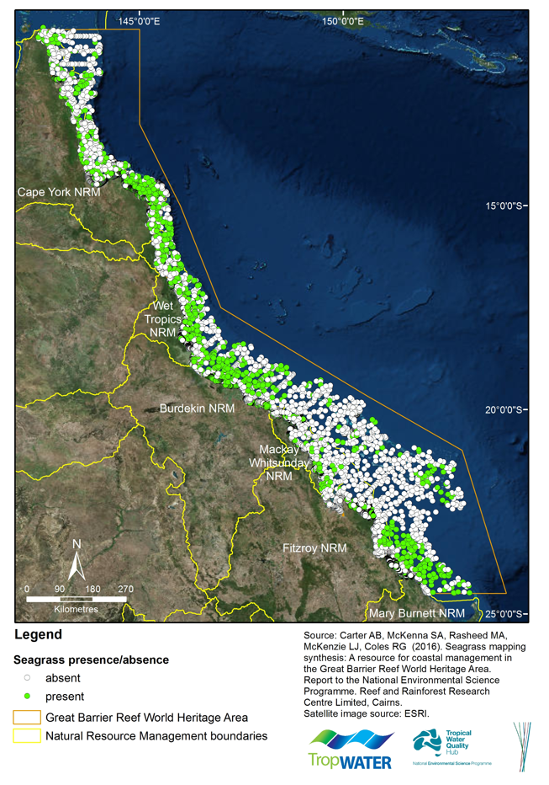

Source: NESP TWQ Round 1 - Project 3.1 - Seagrass mapping synthesis - A resource for marine park and coastal management https://eatlas.org.au/media/2259

Appendix B: Map of the Great Barrier Reef World Heritage Area and Catchment boundaries

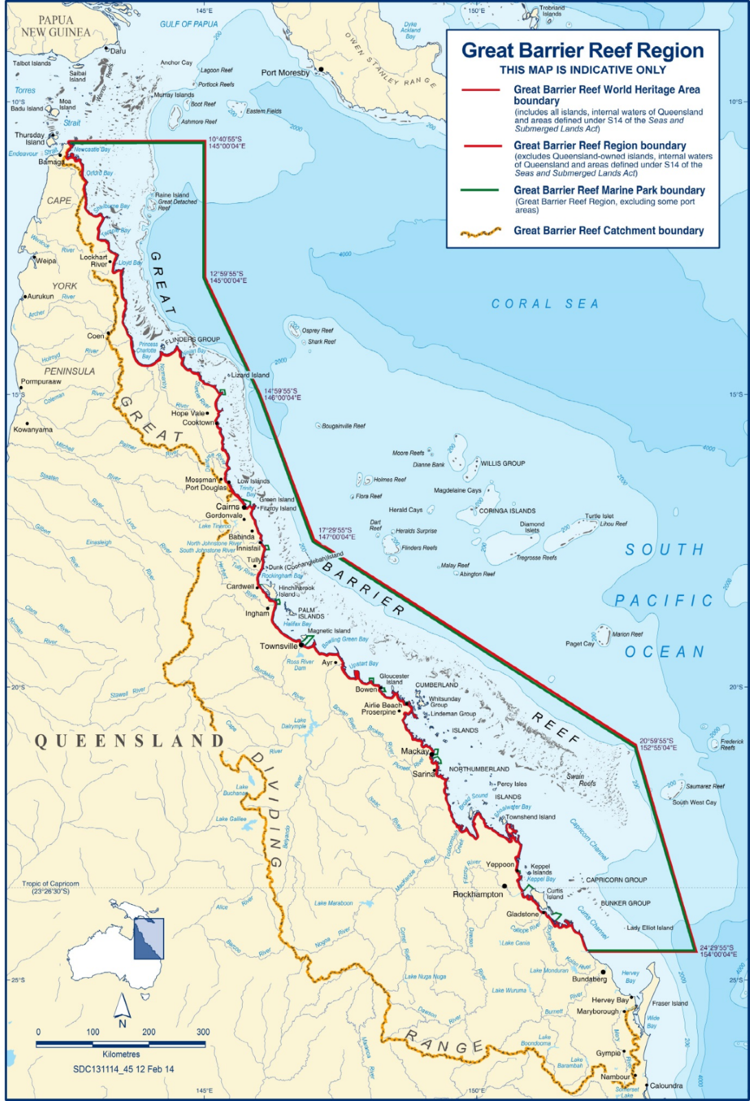
Source: Great Barrier Reef Marine Park Authority (2014), Great Barrier Reef Outlook Report 2014. Available: https://elibrary.gbrmpa.gov.au/jspui/bitstream/11017/2856/5/InBrief_accessible_low%20res.pdf, accessed 24/03/2023.

END

