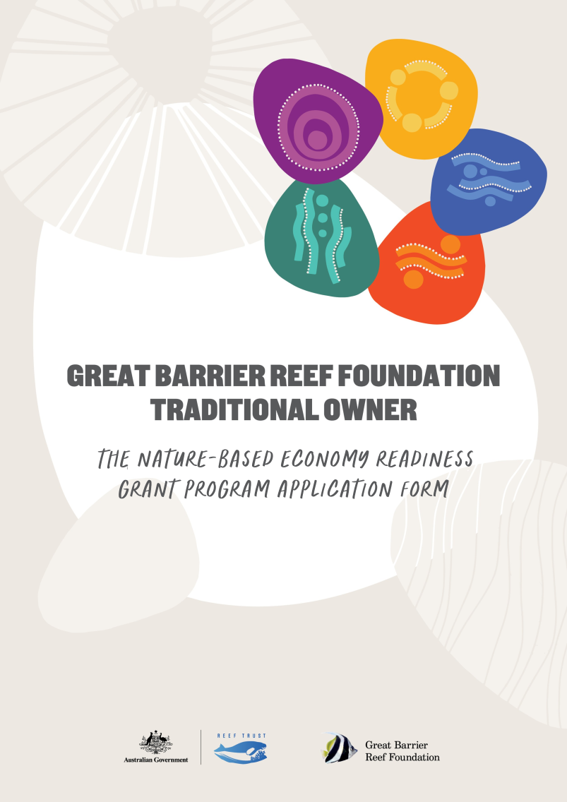
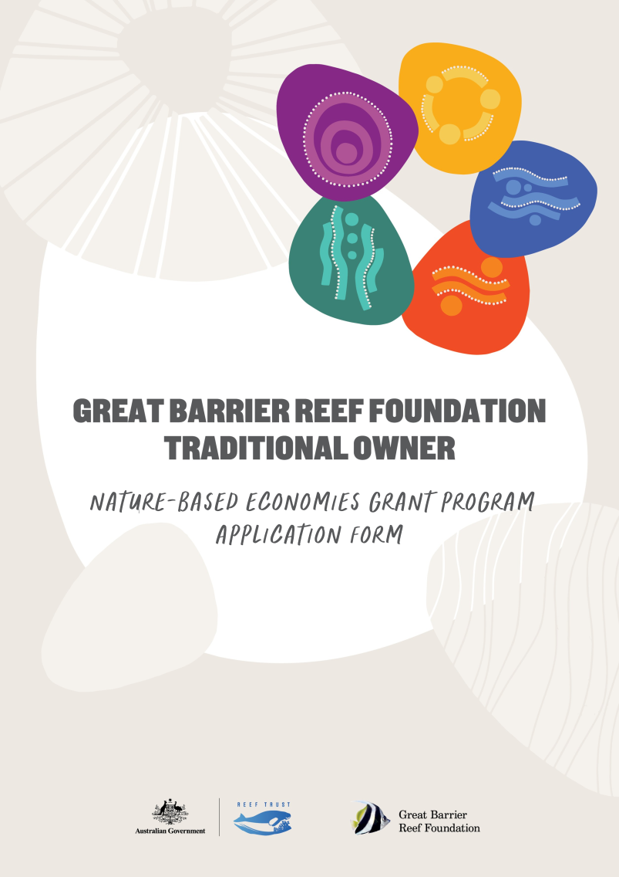
Helping Country
Grant Program
Application Form
Great Barrier Reef Foundation
Traditional Owner

Please email your completed application to: applications@barrierreef.org
- Traditional Owner Group/Sponsor details

1.1 Applicant organisation (Traditional Owner organisation or sponsoring ORGANISATION)
Please fill this out as either the Traditional Owner organisation applying directly for the grant OR as the sponsoring organisation
(NB. The applicant needs to be the organisation that would enter into a funding contract with the GBRF)

Organisation name:

Organisation address:

ABN/ACN:

Website:

Are you sponsoring a Traditional Owner group: Yes ☐ No ☐

1.2 Contact details
Applicant details  (Applicant must be a legal entity—refer page 7 of the Guidelines) | Organisation type  (Traditional Owner) | ☐ Incorporated association  ☐ A body corporate  ☐ A company  ☐ A cooperative society  ☐ A trust duly constituted  ☐ An Aboriginal or Torres Strait Islander corporation or incorporated association  ☐ Other___________________________ (please specify)
 | Organisation type  (Supporting) | ☐ Traditional Owner organisation  ☐ NRM group  ☐ Government body  ☐ Other ___________________________ (please specify)
 | Registered for GST | ☐ Yes ☐ No
Authorised contact person for application  This is usually the person who filled the form out. It should also be the person who can answer any questions about the application. | Name
 | Role within the organisation
 | Email
 | Phone number(s)
Key Personnel 1  This is usually a person who plays a large role in the project’s delivery. | Name
 | Position/Role within the organisation
 | Email
 | Phone number(s)
Key Personnel 2  This is usually a person who plays a large role in the project’s delivery. | Name
 | Role within the organisation
 | Email
 | Phone number(s)
Key Personnel 3  This is usually a person who plays a large role in the project’s delivery. | Name
 | Role within the organisation
 | Email
 | Phone number(s)

1.3 Traditional Owner group details
Traditional Owner group (this needs to be the Traditional Owner group for the Great Barrier Reef World Heritage Area where the Grant Program activities are proposed; see NBE Readiness Grant Guidelines Annexure A).

Traditional Owner group/s:

Contact person for the Traditional Owner group
*(only fill this out if it is different from the contact person nominated in the table above).
Name:
Phone:
Email:

Location details – describe where your traditional Land/Sea Country is and tell us any of the natural features that you are aiming to specifically protect/manage/monitor through the project.
Answer here (maximum 100 words)

Please attach a letter(s) of support from your Traditional Owner organisation(s) (e.g., PBC or other governance arrangement with appropriate cultural authority) endorsing the project and funding application. The letter should describe how Elders/leaders and Traditional Owner community members have been engaged to build understanding and support for the proposal.

1.4 CONSENT FROM LANDHOLDERS
Do you require any consent from landholders to undertake project activities? ☐ Yes ☐ No
If yes, please describe the type of consent required.
Answer here (maximum 100 words)

- Project details

2.1 Project name
Provide a title for the project that you are requesting funding for

Answer here (maximum 15 words)

2.2 which NBE Readiness grant LEVEL are you applying for?
Select the kind of grant you are applying for (details of each level found on page 5 of Guidelines)

- ☐ Level 1 Grant for projects up to $50,000

- ☐ Level 2 Grant for projects between $50,000–$150,000

Note: only ONE application can be submitted per applicant for this grant opportunity.

2.3 Project summary
Please outline the project, how it addresses the Nature-based Economies Grant Program objectives (see page 4-5 of Guidelines), and include:
- why the project is needed, your objectives in undertaking the project and why the project is important to your Traditional Owner group (how it aligns with Traditional Owner priorities and aspirations)
- a description of how the project will enhance your readiness for being involved in nature-based economies
- a brief description of which area of nature-based economy readiness activities you are interested in, for example exploring nature-based economic development ideas, development opportunities, business and project readiness, governance readiness or plan development. See pages 4-5 in the guidelines for more examples of possible project activities.
To assist you in providing the right detail for this section, please refer to Assessment Criterion 2 on page 10 of the Guidelines.
Answer here (maximum 1000 words)
- Project plan

3.1 Project plan timeline and deliverables
Please provide details of the activities and deliverables that would make up your project. These activities will become a series of steps toward achieving the project objectives outlined in the Project Summary above. The activities will also help explain the key components of your project and its delivery against a timeline (see pages 6–8 of the Guidelines for eligible and ineligible activities).

Your timeline should show key project activities and deliverables in chronological order, and the start and end date of each activity. If your application is successful, the deliverables will form the basis of discussion for project milestones and deliverables within the contract.

Your application will be assessed on how well you have planned the project, alignment of deliverables and budget, and whether it represents good value for money (see Assessment Criterion 4 ‘Project Budget’ on page 11 in the Guidelines).

Start date | End date | Activity and deliverables

3.2 Risk management plan
Risk management is a key aspect of sound project delivery. Please attach your organisation’s current Risk Management Plan, or if you may also download and utilise the Foundation’s Risk Management template at https://www.barrierreef.org/what-we-do/grants-and-opportunities/nbe-readiness-grant.

3.3 benefits to traditional owners

Project Development
Answer here (maximum 100 words).

Please describe how the proposal has been informed by Traditional Owner priorities and needs, and how the Traditional Owners (Elders, leaders and broader community) for the Country on which the project is being proposed have been involved in the development of the project proposal.
(see Assessment Criterion 1 on page 12 in the Guidelines for more detail)
Note: Please attach evidence of support from Traditional Owners for the project (e.g, letters, email or short video submission is possible here.
Engagement
Describe how members of your Traditional Owner group will participate and be engaged in this project.

Answer here (maximum 100 words).

Indigenous Employment opportunities
Will your proposed project result in any jobs for Aboriginal or Torres Strait Islander peoples?

☐ Yes ☐ No

If yes, please describe:
- how many people will be employed
- in what capacity will they be employed (e.g. advisory, project management/operations)
- what type of employment (e.g., casual, part-time, full-time), and
- what term will they be employed (i.e., number of weeks, months, or years).

Answer here

3.4 Project budget and value
Include a clear project budget that details project income and expenses. The budget costs must relate to project activities (deliverables) set out in your project plan (see section 3.1 above) and detail the resources and funds required to complete your project. It is important to itemise and describe costs as clearly as you can. Use the table below to detail an estimated project budget.

See pages 6-8 in the Guidelines for detailed information about what is and is not eligible for funding, and funding limitations and Assessment Criterion 4 on page-12.

Some expense ‘types’ have been included in the table below to guide your budget costing. These are examples only
and you should use/include information that is relevant to your project.

Expense item | Total funding by GBRF grant | Total co-funding contributions * | Description of budget items
Staff salaries (please break these down by position and cost)
Operating costs
Program monitoring and evaluation
Project administration (up to 10% of total budget)
Elder fees
Assets etc (list them out with the costs assigned to each item)**
Travel
Catering
Other
TOTAL ($) – excl. GST
*Include relevant in-kind/co-investment contributions and the source of this support/funding
** Quotes should be provided for assets over $5,000 and consultant fees over $15,000

Notes about the example budget items
- operating costs—costs for project delivery (may be costs related to meetings, events, hall hire etc).
- program monitoring and evaluation—a place to include staff and other resources required for program level tracking on project progress and outcomes (not environmental monitoring).
- project administration—covering organisational overheads (e.g. audit costs) and cannot be more than 10% of the total budget.
- In-kind support/co-investment can include volunteer time (valued at $45.63/hour as per Volunteering Queensland figures), partner support and external support

4. Delivery capacity

4.1 Governance arrangements and previous project experience
Describe any governance arrangements that are in place that can support or assist the running of the project. For example: a Steering Committee for other projects, PBCs, access to office and admin support staff, rangers, working groups etc.

Also provide details on any previously completed projects and describe the outcomes of the projects (see Assessment Criterion 5 on page 11 of the Guidelines for more details).

Answer here (maximum 500 words).

5. Communication and engagement

5.1 Communication
Describe how you will tell your group and others about your project, including how (and how often) you will monitor and report on its progress. Describe how you will communicate the final project outcomes to your group and to others, such as other Traditional Owner groups, key partners, and the broader community
(see Assessment Criterion 6, on page 11 of the Guidelines for more detail).

Answer here (maximum 250 words).

5.2 Engagement and partnerships
Are there any other organisations that you will work with/engage in the delivery of your project? If yes, please provide details in the table below.

Partner organisation name | Key contact name, phone and email | Role within the project
Please attach a letter of support from each project partner describing the partnership arrangement for the project. Additional support letters from relevant organisations demonstrating wider community support for your project will also assist your application in the assessment process.

5.3 Expected Organisational outcomes
As a result of the grant funding, what is the total number of jobs (as FTE’s) that you expect to be supported throughout the grant term? Will any new roles be created? If so, how many?

Refer to the worked example below to assist with your calculations.
Worked example:
Employee type | Worked example | FTE value
Full-time equivalent employee | Approximately 76 hours per fortnight OR 10 days per fortnight per person | 1 FTE
Part-time employee (this example is 4 days per fortnight) | Calculated based on the full-time equivalent.  4 days / 10 days = 0.4 FTE | 0.4 FTE
Casual employee  (this example uses an average of 15.6 hours a fortnight) | Calculated based on the full-time equivalent.  15.6 hours / 76 hours = 0.2 FTE | 0.2 FTE
Total FTE | Sum of all employment | 1.6 FTE

*Calculate contracted employees using the Full-time equivalent method, then specify the duration of their contract. For example; 0.5 FTE – 6 month contract

6. Reporting

6.1 Project reporting
☐ Tick this box to indicate that you agree that you will retain all Intellectual Property Rights from your project material but will provide summary project data for reporting during the term of the project to facilitate timely communications and reporting. Reporting will be developed in consultation with successful project applicants and relevant data users but will be required at a minimum every six months across the duration of the project.

7. Mandatory information required with successful grant

7.1 Eligibility criteria

Eligibility Criteria
Applicant is a Traditional Owner group for the Great Barrier Reef and/or Catchment Area | ☐ Yes / ☐ No
Applicant is operating in Australia and has supplied an Australian Business Number (ABN) | ☐ Yes / ☐ No
Applicant holds, or is willing to hold, the required insurances. The following insurance types may be expected:  - Workers’ compensation  - Public Liability (minimum required: $20,000,000 per occurrence)  - Professional Indemnity (amount to be determined at a later date)  - Motor Vehicles and Plant and Equipment Insurance (if applicable) | ☐ Yes / ☐ No
Applicant has developed and implemented comprehensive WHS policies and procedures for the project, or is willing to:  - undergo a WHS risk assessment  - take all reasonable steps to manage identified risks, and  - undergo specific training or qualifications that the Foundation recommends prior to commencing the project. | ☐ Yes / ☐ No
Applicant accepts the terms and conditions of the application including the specified terms in the sample agreement template | ☐ Yes / ☐ No
Applicant has completed all sections of the form | ☐ Yes / ☐ No
Applicant has provided all necessary supporting documents | ☐ Yes / ☐ No

7.2 Conflict of Interest Declaration
The following information is disclosed for the purposes of this Application. The Applicant must provide details of any actual, perceived or potential conflicts of interest that exist or may arise in connection with the provision of technical services. Successful candidates will be required to execute a conflict declaration upon contracting.

In submitting this Application, the Applicant acknowledges and warrants that to the best of their knowledge and belief, and subject to any disclosures detailed below:
- no family, business or pecuniary relationships exist between the Applicant and GBRF
- neither the Applicant not its officers, employees, contractors, or family members have:
- engaged in any unethical behaviour or sought and/or obtained an unfair advantage; or
- received or will receive any pecuniary in in-kind advantage from any other Applicant.
In relation to this Application process:
- no officer, employee, contractor or family member associated with the Applicant is or has been engaged by GBRF in a position or role that in any way related to the application;
- no officer, employee, contractor or family members associated with GBRF has been offered any benefit or inducement associated with this Application, including any offer relating to employment; and
- other than specified below, neither the Applicant nor any of its officers, employees, contractors, or family members have or are likely to have any Conflict of Interest.
The Applicant further undertakes to immediately notify GBRF in writing if any warranty contained in this Application Form becomes, or may become, incorrect.
Are there any Conflicts of Interest to declare?
☐ Yes | ☐ No
Please outline any details of any actual, perceived or potential conflicts of interest that exist or may arise in connection with the provision of technical services: | ☐ No
Please detail how you propose the Conflict should be managed/resolved: | ☐ No

7.3 Declaration in relation to key personnel
Key personnel of the Applicant who have a role in the management of the project are required to be fit and proper persons.

☐ By checking the box, the Supplier confirms all Key Personnel are:
- not a person who is an undischarged bankrupt;
- not a person who has in operation a composition, deed or arrangement with his or her creditors under the law relating to bankruptcy;
- not a person who has suffered final judgement for a debt and the judgement has not been satisfied;
- not a person who has been convicted of an offence within the meaning of paragraph 85ZM(1) of the Crimes Act 1914 (Cth) Part VIIC; and
- not a person who is or was a Director or occupied an influential position in the management or financial administration of an organisation that has failed to comply with the grant requirements or obligations owed to the Commonwealth.
If any of the above criteria do apply to Key Personnel, applicants must provide details below:

8. Declaration
The Applicant:
- acknowledges that the information provided by Great Barrier Reef Foundation was provided for the convenience of Applicants, and that the Great Barrier Reef Foundation will not be liable for any information provided or for any errors or omissions form such information
- ensures that all the information contained in the Applicant’s offer is complete, accurate, up to date and not misleading in any way
- offers to provide the project to the Great Barrier Reef Foundation in accordance with the information, standards, warranties, and representations in this Application form and accompanying documentation, and the terms of the contracting instrument
- acknowledges that the Great Barrier Reef Foundation will rely on the information contained in the application (including the warranties and declarations) when deciding whether or not to accept the application and that if the Great Barrier Reef Foundation accepts the application, the Great Barrier Reef Foundation will enter into a Funding Agreement relying on that information
- agrees to contact Great Barrier Reef Foundation immediately if any information provided in this application changes or is incorrect
- gives permission for Great Barrier Reef Foundation to verify funding requested from other funding agencies in support of this application and to provide information in this application to those funding agencies for this purpose
- consents that information provided in this application may be provided to Great Barrier Reef Foundation’s project partners, including Australian and Queensland Government agencies, and that summary information across the grants program may be shared publicly (for example the number of applications, total funds requested and themes of projects)
- acknowledges that, if this application is successful, information provided in this application will form part of a funding agreement with Great Barrier Reef Foundation and their organisation will be held accountable to the project deliverables outlined in this application (including any attachment)
- consents that, if this application is approved, summary information about this grant application may be published in any announcement about grant programs including the applicant’s name, description of the project, value of grant provided, commencement date and any other information deemed relevant to the announcement, and
- represents that the signatories below are authorised to execute this Application Form on behalf of the applicant.

☐ I understand and agree to the declaration above.

Name of Authorised Representative
Date

By submitting this application form you agree that your information will be used in accordance with GBRF’s Privacy Policy.

Questions about this application Form can be emailed to the Great Barrier Reef Foundation Grants Office at grants@barrierreef.org

Please email applications to: applications@barrierreef.org
by 5.00pm AEST, Wednesday 18 March 2026.

